MOBILE NETWORK ACCESS DEVICE FOR USE WITH THE DHS ADVANCED CONTAINER SECURITY SYSTEM

A Thesis
Presented to the
Faculty of
San Diego State University

In Partial Fulfillment
Of the Requirements for the Degree
Master of Science
in
Electrical & Computer Engineering

By
Sergio Enriquez
Spring 2012
SAN DIEGO STATE UNIVERSITY
The Undersigned Faculty Committee Approves the
Thesis of Sergio Enriquez:
Mobile Network Access Device for use with the DHS Advanced Container Security System

Yusuf Ozturk, Chair
Department of Electrical and Computer Engineering

Sunil Kumar
Department of Electrical and Computer Engineering

Joseph Lewis
Department of Computer Science

Approval Date
Copyright ©2012
by
Sergio Enriquez
All Rights Reserved

ABSTRACT OF THE THESIS
Mobile Network Access Device for use with the DHS Advanced Container Security System
by
Sergio Enriquez
Master of Science in Electrical & Computer Engineering
San Diego State University, 2012

With the aim of improving the security for shipping containers using in a global supply chain, the Department of Homeland Security is developing the technical requirements for an open Container Security System communications interface. The primary purpose of this system is to monitor the status of shipment containers equipped with electronic chain of custody devices, and channel this information to a secure data consolidation server. This application is intended to integrate with and extend the functionality of the Department of Homeland Security’s Advance Container Security System. By replicating most of the functionality provided by a Data Consolidation Server, a handheld unit can be used to provide users with a secure and convenient method to wirelessly monitor and control the status of the container security devices in the area. Once a user has obtained the necessary security keys to enable wireless communication with the security devices, the handheld unit will then join an existing 802.15.4 wireless network and permit the secure exchange of information between itself and the security devices. The current application was developed in Java can be run using a standard Android phone, provided that the USB-to-XBEE dongle is also available.

TABLE OF CONTENTS
PAGE
ABSTRACT…………...…….……………………….……………………….…………..….iv
TABLE OF CONTENTS v
LIST OF FIGURES viii
LIST OF TABLES x
ACKNOWLEGEMENTS xi
CHAPTER xi
CHAPTER 1 INTRODUCTION 1
CHAPTER 2 DHS CARGO SECURITY TEST PROGRAM 2
2.1 Background 2
2.2 Project Scope 2
2.3 System Components 2
2.4 System Security 2
2.5 ICD Communication Overview 2
2.6 Network Communications Overview 2
CHAPTER 3 ICD COMMUNICATION SPECIFICATION 3
2.1 Network components 3
2.2 Network discovery 3
2.3 Message types 3
2.4 Communication Sequence diagrams 3
CHAPTER 4 NETWORK COMMUNICATION SPECIFICATION 4
2.1 Authentication and Key Management Server Role 4
2.2 Data Consolidation Point Messages 4
2.3 Key Management Facility Messages 4
CHAPTER 5 SYSTEM SECURITY OVERVIEW 5
2.1 KMF role 5
2.2 Key creation 5
2.3 AES encryption overview 5
CHAPTER 6 HANDHELD NETWORK ACCESS DEVICE 6
6.1 Requirements 6
6.2 Design Choices 7
6.3 Overview of Android OS 8
6.3.1 Android Activities 9
6.3.3 Android ADK 10
6.4 HNAD Application 11
6.4.1 Use Case 11
6.4.2 Activities 12
6.4.2.1 UI Design 12
6.4.2.2 Login Activity 13
6.4.2.3 Configuration Activity 14
6.4.2.3 Devices in Area Activity 15
6.4.2.3 Device Details Activity 17
6.4.2.3 Device Log Activity 19
6.4.2.3 Device Keys Activity 20
6.4.2.3 Trip Info Activity 21
6.4.2.3 HNAD Log Activity 22
6.4.3 Program Structure 23
6.5 HNAD Components 24
6.5.1 HNAD Service 25
6.5.1.1 NADA Broadcaster 26
6.5.2 USB Control Process 27
6.5.3 XBee API 28
6.5.4 Database Handler 29
6.5.5 Network Components 30
6.5.5.1 Web Client 30
6.5.5.2 FTP Client 30
6.5.5.3 TCP Client 31
6.6 ICD Message Handling 31
6.6.1 Cargo Security Components 31
6.6.2 ICD 802.15.4 Messages 32
6.6.3 ICD Network Messages 34
CHAPTER 7 USB TO XBEE BRIDGE 35
7.1 Operation 35
describe code 35
7.2 Components 35
7.2.1 XBee RF Module 35
7.2.2 XBee RF Module 35
7.2.3 Arduino FIO Board 36
CHAPTER 8 AUTHENTICATION WEB SERVER 37
8.1 Scope of Current Implementation 37
8.2 Administration Role 37
8.3 Java Servlets Overview 38
8.4 Tomcat Server 38
8.5 FTP Server 38
8.6 Future Work 38
CHAPTER 9 CONCLUSION 39
BIBLIOGRAPHY 40

LIST OF FIGURES
Figure 1: HNAD functionality compared to other system components 6
Figure 2: Components of the Android Architecture [2] 8
Figure 3: The Android activity lifecycle [2] 9
Figure 4: Sample ADK compatible board 10
Figure 5: A normal use case for the HNAD application 11
Figure 6: HNAD Activities 12
Figure 7: Screenshot of the Login Activity 13
Figure 8: Screenshot of the Configuration Activity 14
Figure 9: Screenshot of the Configuration Activity 16
Figure 10: Screenshot of the Configuration Activity, part 1 17
Figure 11: Screenshot of the Configuration Activity, part 2 18
Figure 12: Screenshot of the device log activity 19
Figure 13: Screenshot of the edit device key activity 20
Figure 14: Screenshot of the edit trip info activity 21
Figure 15: Screenshot of HNAD log activity 22
Figure 16: Separation of application components 23
Figure 17: Relation between HNAD service and other components 24
Figure 18: HNAD service class 25
Figure 19: USB Manager components 26
Figure 20: XBee API class 27
Figure 21: Database management classes 28
Figure 22: Network component classes 29
Figure 23: ICD component devices 30
Figure 24: ICD Message class 31
Figure 25: ICD 802.15.4 Message payloads 32
Figure 26: ICD network messages 33
Figure 27: XBee RF Module 34
Figure 28: USB Host Shield for the Arduino Pro 34
Figure 29: Arduino FIO board 35
Figure 30: Login Steps 36
Figure 31: Authentication Sequence 37

LIST OF TABLES
Table 1.1 First Table in Chapter 1 2
Table 2.1 First Table in Chapter 2 3

ACKNOWLEGEMENTS
I wish to thank my advisor, Dr.Yusuf Ozturk, for the advice and encouragement he provided throughout the planning and development of this project. His guidance was invaluable in helping to get the project going and keeping it on schedule.
I would like to thank Dr. Sunil Kumar and Dr. Joseph Lewis for serving on my thesis committee and helping to improve the quality of this thesis.
Special thanks go to Russ Clement for the advice provided, and helping to obtain the necessary funding for this project.

CHAPTER

CHAPTER 1
INTRODUCTION
Topics for this section:
- Definition of the problem addressed by DHS project
- Need for electronic container security and central management
- Other approaches taken by similar projects
- Brief overview of DHS program
- Brief overview of handheld access device role

CHAPTER 2
DHS CARGO SECURITY TEST PROGRAM
Discuss the aim and scope of the DHS project, driving motivation

2.1 Background
[History of project, milestones, future work]

2.2 Project Scope
Commercial vs government data, centralized control

2.3 System Components
DCP,KMF, level 2 facilities, level 3 devices etc

2.4 System Security
Overview on how is data kept secure to prevent unauthorized access or tampering

2.5 ICD Communication Overview
Overview of ICD communication, message types, commands,

2.6 Network Communications Overview
Overview of NAD to DCP comm, key transmission, etc

CHAPTER 3
ICD COMMUNICATION SPECIFICATION
What is encompassed by the specified standard

2.1 Network components
a

2.2 Network discovery
b

2.3 Message types
c

2.4 Communication Sequence diagrams
d

CHAPTER 4
NETWORK COMMUNICATION SPECIFICATION
Discuss the messages passed from NAD/HNAD to DCP. Suggested method to authenticate users and obtains keys (not part of standard)

2.1 Authentication and Key Management Server Role
Discuss suggested method used on this project

2.2 Data Consolidation Point Messages
Refer to NAD requeriments and communications document

2.3 Key Management Facility Messages
Not part of standard, suggested implementation

CHAPTER 5
SYSTEM SECURITY OVERVIEW
Overview of how ICD communication is kept sequre

2.1 KMF role
b

2.2 Key creation
c

2.3 AES encryption overview
d

CHAPTER 6
HANDHELD NETWORK ACCESS DEVICE
The purpose of the handheld network access device (HNAD) is to provide the means for an individual to monitor and administer the container security devices (CSDs) in a dock site by possessing the ability to decrypt and encrypt the ICD messages used by these devices. The main difference to the standard fixed network access devices (FNAD) and DCP being that this unit is both portable and capable of producing both restricted and unrestricted ICD commands. As part of the cargo security program, the HNAD software shall run on commercially available smart phones in order to demonstrate the functionality of the system.

6.1 Requirements
According to the requirements stipulated in [1], and HNAD unit may operate in the following three different modes:
- Non-Secure: The device acts as a mobile transparent bridge between the DCP and the CSDs that are located in a site.
- Arming only: The device can only generate and send the arm command to a CSD
- Secure: The device will be able to process and generate all restricted and unrestricted commands as described in the ICD.
For this implementation, the HNAD will only operate in the secure network access device mode. Figure 1 compares the role of the HNAD to the other components of the cargo security program:
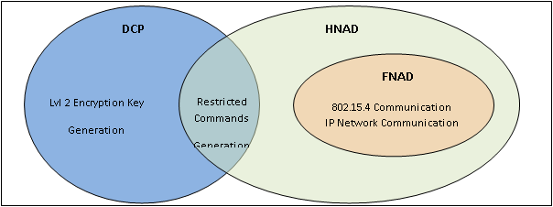
Figure 1: HNAD functionality compared to other system components

As described in chapter 5, the HNAD is a security level 2 device, therefore it will only posses temporary use encryption keys and it will rely on an external server to act as the key generator and repository of this data. Once a user has authenticated himself with an external server, the handheld unit shall then download the necessary encryption keys to work with the CSD that have been assigned to him.
As a secure NAD, the HNAD shall be capable of storing all the event logs received from the CSDs it communicates in addition to the logs generated by recording all the user activity on the handheld device. Being a handheld unit with relatively small storage space compared to the DCP server, the HNAD should transfer the stored logs the DCP at the end of a work session when internet access is available.

6.2 Design Choices
To meet the previously mentioned requirements, it was decided to implement the HNAD application using a standard phone running the Android OS. The reason for this was because it is a very widely used Smartphone OS, the ease of application development, and the availability of an “accessory” USB mode that enables communication with external USB hardware that conform to a freely available standard. As of the date when this application was being developed, there were no commercially available android devices with a built in IEEE 802.15.4 radio module, so it was decided that connecting a commercially available XBee RF Module would be a suitable way to test the integration of the HNAD with the existing CSD wireless network. This USB to 802.15.4 bridge is covered in detail chapter 8.
It is expected that in the near future such devices will become available and provide a lower power alternative to wireless networking compared to WiFi and Bluetooth, and be used with existing Home Automation devices.
In addition to this, there is a growing selection of ruggedized tablets running the Android OS. It is expected that the HNAD will be operating on a variety of outdoors environments, so it will be important the unit be capable of enduring rough treatment and its screen be readable in direct sunlight and be usable by employees wearing gloves. Figure 2.2 shows an example of a ruggedized tabled that can run the Android OS.

An important design goal was for the application to be intuitive to use and require minimal user training. The Android OS provides the functionality to adjust the users interface to fit in a wide variety of Smartphone screen resolutions, and if necessary create custom UIs that are better suited for use on wide screen tables.

6.3 Overview of Android OS
Android is a Linux-based operating system designed for use on mobile devices such as Smartphone’s and tablet computers. The freely available Android SDK provides all the necessary tools to begin application development using Java as the default programming language [2]. Figure 2 illustrates the major components of the Android OS:
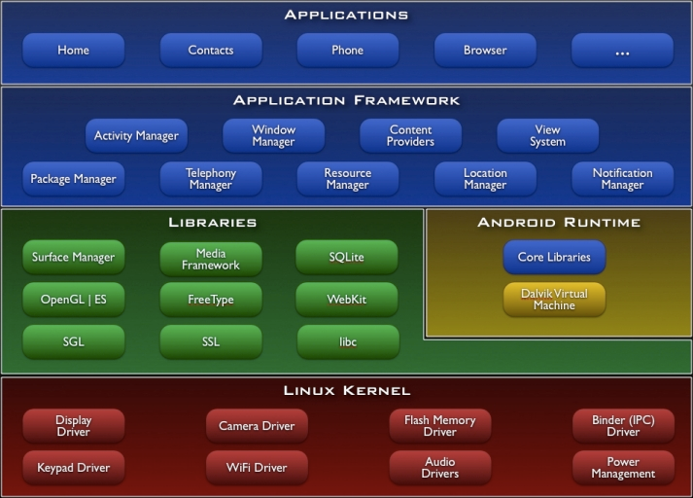
Figure 2: Components of the Android Architecture [2]
Android’s kernel is based on the Linux 2.6 kernel, but it does not include support for its native windowing service or GLIBC support, so it will be difficult to port existing Linux libraries or programs to Android [3]. In a similar case, Android employs its own custom Java virtual machine that is incompatible with other Java runtime environments, so existing Java programs cannot be ported to run in it. On the upside, Android supplies a well organized and easy to use API integrates deeply with the supported hardware platforms.

6.3.1 Android Activities
In the Android API, an activity is defined as a single focused thing that a user can interact with. Usually an activity will be presented to the user as a full screen window, and will have associated with it an XML based UI layout and a set of menu options that appear when the user pressed the MENU hardware button. Using the invoke API call, the application can request that the OS launch the appropriate activity that has been register to handle a particular intent. During its lifecycle, an activity can become suspended if the user navigates to a different application or if the screen is turned off.
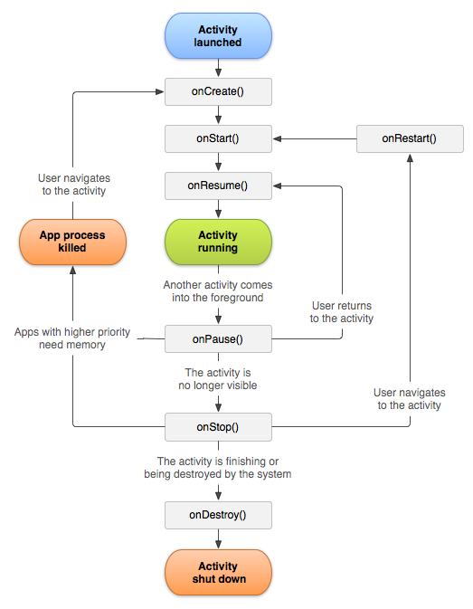
Figure 3: The Android activity lifecycle [2]
6.3.2 Android Services
In the cases where it is necessary that a long running process not be interrupted when an activity loses focus, on should instead use a service component. The service provides the mean to continue to perform some monitoring or work in the background even though the activity that started is no longer in focus or running, and will continue to work until it is explicitly stopped. To exchange data between activities and services, one could pass each activity a reference to the running service, or register each component to respond to the appropriate broadcast messages generated by the application.

6.3.3 Android ADK
With the Android 2.3.4 platform, Google introduced the Android Open Accessory Development Kit (ADK) which allows external USB hardware accessories to interact with Android powered devices. However, a downside is that supporting USB accessories will act as a USB host and need to provide 500mA at 5V. A particular activity or service can be registered to run whenever a certain type of USB accessory is connected to an Android Device, in which case it will be able to communicate with it as if it was a standard serial port. From the USB host point of view, the Android device will behave like a standard USB accessory and can be managed accordingly.
Figure 4 shows an example of an ADK compatible board that can be used to interface an Android device with a wide variety of external sensors or control devices.
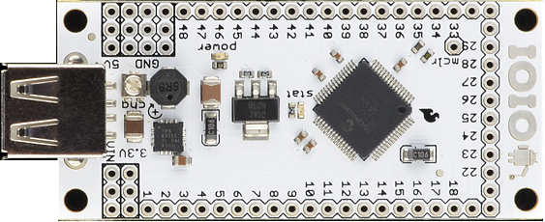
Figure 4: Sample ADK compatible board

6.4 HNAD Application
The HNAD application was designed to be easy to use and require minimal configuration by its user. Under normal operation the application will come preconfigured with the address of the central consolidation and authentication servers, all the user will simply need to enter his login credentials to begin using the application. On chapter 8, the operation of the authentication server will be covered in more detail.

6.4.1 Use Case
Figure 5 illustrates the actions that can be taken by the HNAD user. Each authorized user will first authenticate with the server to confirm he has permission to use the device and obtain the temporary encryption keys for the CSDs that were assigned to his work orders. With the keys stored on the HNAD unit, the user will be able to check that the CSD/ECOC devices are in good working order, retrieve their event logs from the previous trip, or arm them for operation on the next one. After retrieving the necessary logs for all the assigned devices, if the HNAD unit has internet access, the user can issue a command to begin uploading the stored logs to the DCP server.
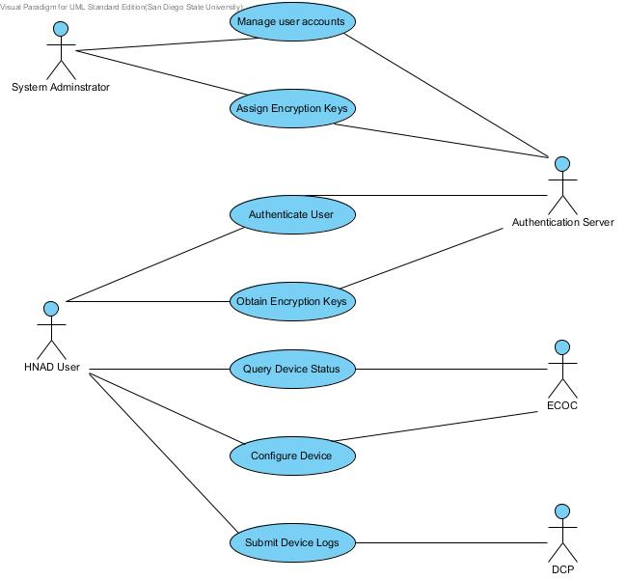
Figure 5: A normal use case for the HNAD application

6.4.2 Activities
In order to simplify the use of the application, the number of activities was kept at a low number, and their nesting level was kept below two levels deep. When the program is first launched either by the user or by connecting the appropriate USB accessory, the HNAD service will be started and the Login screen will then be displayed. Figure 6 below illustrates the user screen transitions for the application:
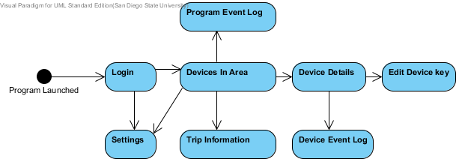
Figure 6: HNAD Activities
In order to save time and make it easier to maintain the application, all the activities in the application will be subclasses of the base HNAD activity. In this Activity the necessary service bindings and broadcast receivers’ will be registered with the OS since every activity will need to send and receive messages from the core functionality provided by the service.
Should the user successfully authenticate and then switch to a different application, the next time the application is launched the HNAD service will remember this, and take the user to the ‘Devices in Area’ activity. If the user logs out or turns off the device, then they will be taken to the login activity the next time the application is launched.

6.4.2.1 UI Design
This application was tested using the MyTouch2 Android phone, so the user interface and menus were designed to be easy to read and interact with given the screen resolution of a standard Smartphone. However, thanks to the functionality provided the Android API, it is very simple to add custom UI layouts that are better suited to the screen resolution of a tablet. Also, as a common element every screen will display an icon on the top right corner that will indicate if communication with the USB to Xbee bridge is working.

6.4.2.2 Login Activity
From this screen the user can enter his login credentials and submit them to a previously configured authentication server. If the “Remember Account” checkbox is marked, then the next time the application is launched it will try to authenticate immediately and proceed to the next screen. If the user presses the “Exit Program” menu button the application will exit and stop the background HNAD service. Figure # displays a screenshot of the login screen.
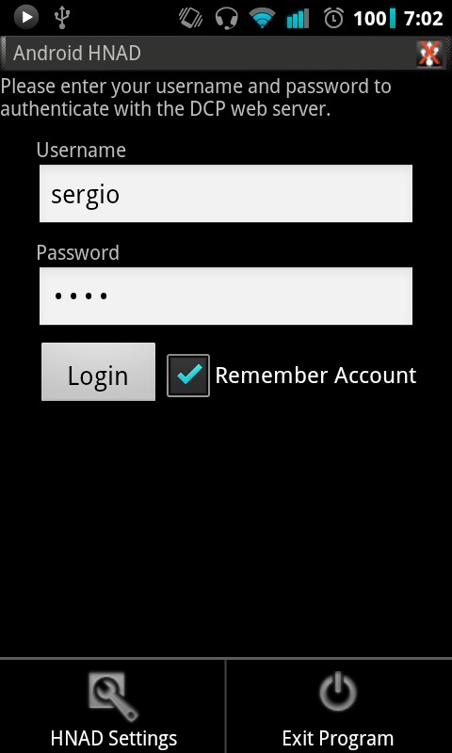
Figure 7: Screenshot of the Login Activity

6.4.2.3 Configuration Activity
From this screen the user can specify the internet address of the authentication server, whether to employ encryption on the ICD messages, and the NADA message transmission rate. The user can also view the HNADs and DCP’s UID and address. These three last settings are normally not changeable by the HNAD user, so they are merely displayed for reference and for debugging purposes.
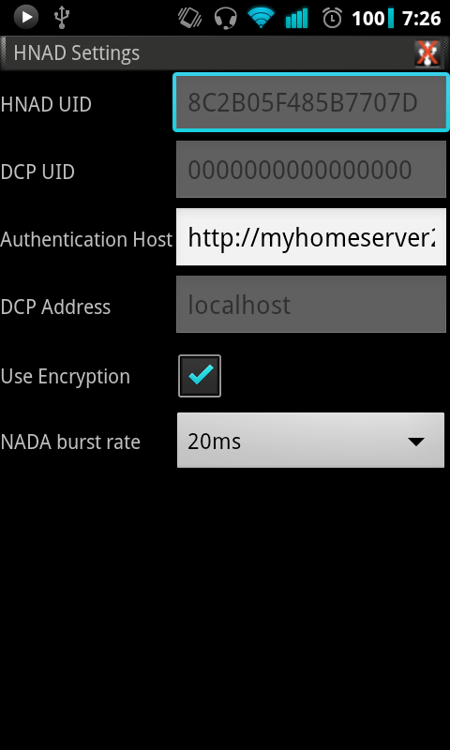
Figure 8: Screenshot of the Configuration Activity

6.4.2.3 Devices in Area Activity
This is the central activity of this application. From this point the user can view any CSDs in radio range as well as those seen in the past or those included in the encryption keys package received form the authentication server. From this screen the user can click on the row for a device to be taken to the selected device’s details screen, or long press on the item to display a context menu with a list of possible commands to send to this device. The following is a list of the UI elements:
- RSSI: The number of bars represents received signal strength level based on the reported RSSI value from the XBee module’s API as it receives packets from each CSD. It ranges from -30dBm to -100dBm.
- UID/Type: The unique ID and device type identifying each CSD.
- Key: A key icon will be displayed if the HNAD possesses the encryption key that belongs to this device.
- Armed: A lock icon will be displayed if the device’s mode is set as commissioned for operation.
- Alarm: Displays the number of alarm statuses that are triggered.
- USB icon: If the icon displays a red X, then a compatible USB Bridge has not been connected to the Android device.
- HNAD settings: Go to the settings activity
- Log out: Stops the USB bridge, and returns to the login activity
- Event log: Go to the HNAD log activity
- Edit Trip info: Go to the trip info activity
- Set Discovery On: Changes the 802.15.4 network announcement broadcast to request that every device in range transmit a NULL status message. This is useful for quickly learning what devices are in radio range.
Figure # below displays the different elements of this layout:
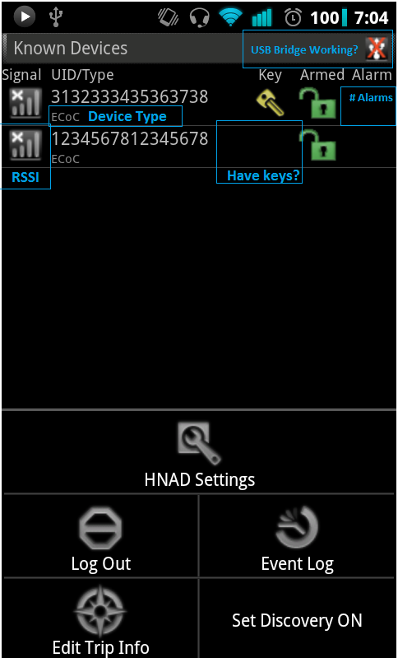
Figure 9: Screenshot of the Configuration Activity

6.4.2.3 Device Details Activity
From this screen the user can view all the status and alarm information for the selected CSD as well as sending a several secured commands. Upon first loading this screen most of the fields will be empty, so a query message will be sent automatically to the CSD in order to obtain its status information. Depending on the status reply, the appropriate status or error boxes will be marked. Figure 10 and Figure 11 show a screenshot of this screen, which is longer than the vertical area of the Android device, so it will be necessary to scroll down to view all the status boxes.
a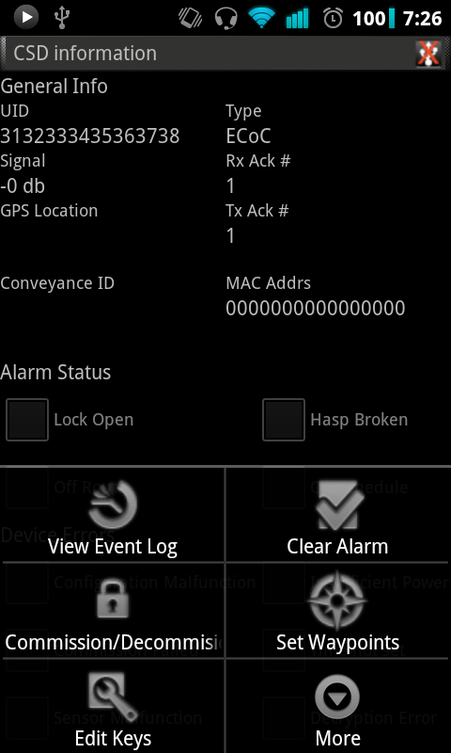
Figure 10: Screenshot of the Configuration Activity, part 1
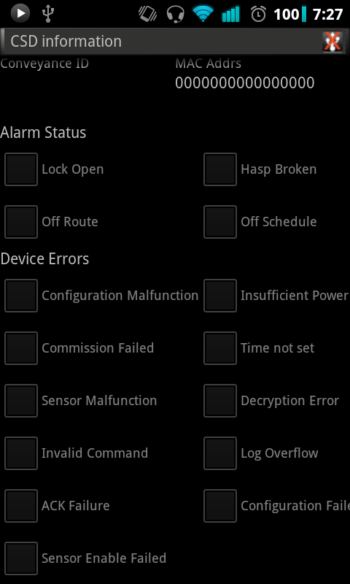
Figure 11: Screenshot of the Configuration Activity, part 2
The current implementation supports sending the following ICD commands:
- Query Restricted status
- Query Un-restricted status
- Clear alarm and error status
- Commission device
- Decommission device
- Set trip waypoints
- Clear Event logs
- Set Time
- Retrieve event log

6.4.2.3 Device Log Activity
Upon entering this activity, a retrieve logs command will be sent automatically to the selected device. While this is processed, the user can view the previously received logs that were stored in the local database. Every log item is composed of the following items:
- Records number: A serially incrementing number starting at 1
- Timestamp: When the event took place
- Event type: Event type that triggered this log
- Data: Four code values representing the operating mode, status code, error code, and lock code of the device when the event took place.
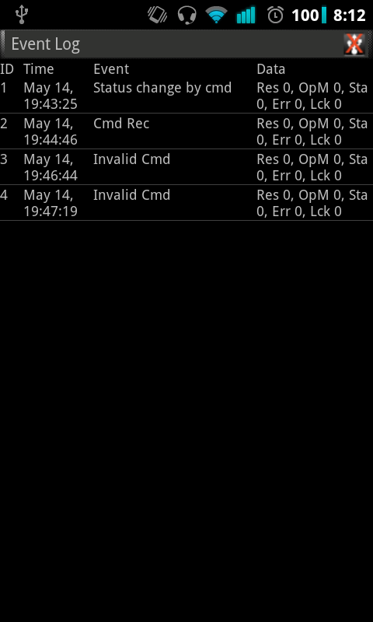
Figure 12: Screenshot of the device log activity

6.4.2.3 Device Keys Activity
This screen is used to alter or delete the temporary encryption key and ascension number belonging to a particular device. It is not meant to be used during normal operation, and is only included for debugging purposes.
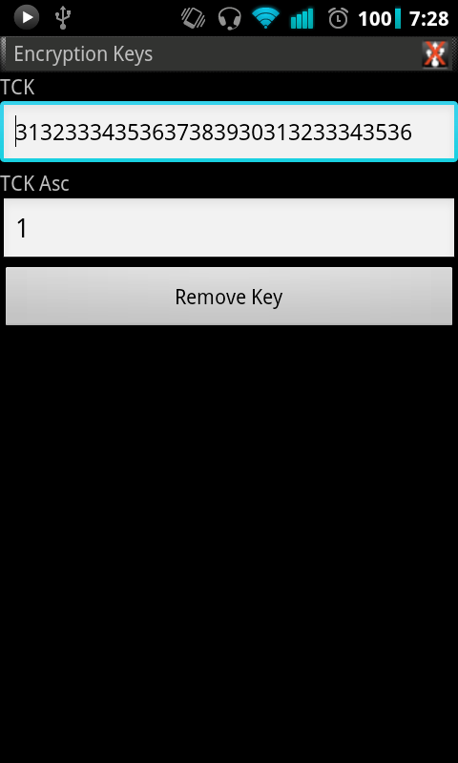
Figure 13: Screenshot of the edit device key activity

6.4.2.3 Trip Info Activity
From here the user can set the conveyance ID and the GPS waypoints that are to be configured into each CSD in preparation for an upcoming trip. Long pressing on a waypoint item will bring up a context menu to edit or delete it. In a future implementation this information should be received from the authentication server upon a successful login, but for this implementation this screen will be used to enter it manually.
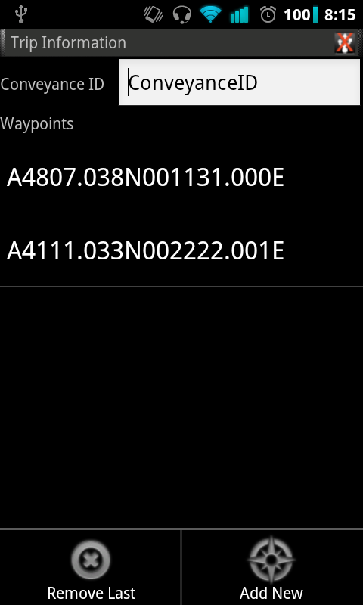
Figure 14: Screenshot of the edit trip info activity

6.4.2.3 HNAD Log Activity
This screen displays every logged HNAD event recorded on the local database. A new record is created for every ICD message sent, when a user attempts to login, and when the application is launched or closed. Each record has the following items:
- ID: A unique record ID
- Time: When the event took place
- User: Who was logged in, or attempted to login
- Event: The type of event
- Destination: UID of the destination device for this a generated ICD message
- Command: The ICD command type sent
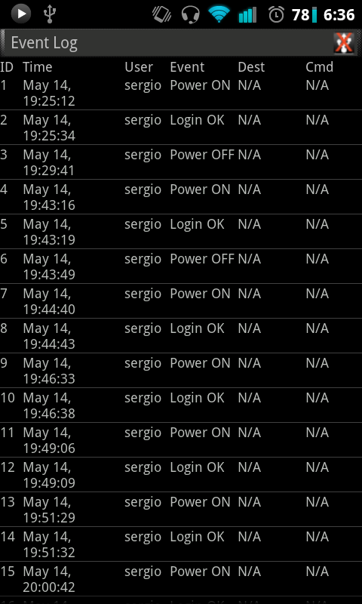
Figure 15: Screenshot of HNAD log activity

6.4.3 Program Structure
The main design goal for developing this is application was for it to be structured in a fashion that makes it easier to modify and adapt so it can run on a different platform in the future. The program logic for parsing, generating, and encrypting ICD messages is kept on a separate package that is not dependent on the Android API, and in a similar manner the UI layout, user interface management, and background system components are kept separate from each other so that more of the code can be reused. Figure 16 illustrates the organization of these components.
HNAD
Android
Application
Shared ICD Code Base
UI Layout
Activities
HNAD Background Service
ICD Message Parser/Generation
USB / Network Handlers
Figure 16: Separation of application components
The majority of the logic processing will be performed by a single HNAD service object which will act as the main controller class in the project. Each activity possesses a reference to this service and will make synchronous and asynchronous calls such as querying local database information or request that a message be sent to an external entity. In addition to this, in order to respond to asynchronous responses each activity has a broadcast receiver object which can be registered to receive and processes a particular set of broadcast messages that the HNAD service generates.

6.5 HNAD Components
Figure 17 displays how the different functions provided by the HNAD are organized into different classes. There a single instance of the HNAD service running on the handheld at a time, and in turn this instance will create and initialize each of the other components when it is first created. In the cases where the objects run their main process on a separate thread, arriving messages will be forwarded to the HNAD service by making use of Android’s asynchronous message handling functionality. Once initialized, the USB and network manager objects will be running in the background on their own separate threads, while the DatabaseHandler, FtpHandler, and WebHandler objects are executed only when a data resource needs to be retrieved.
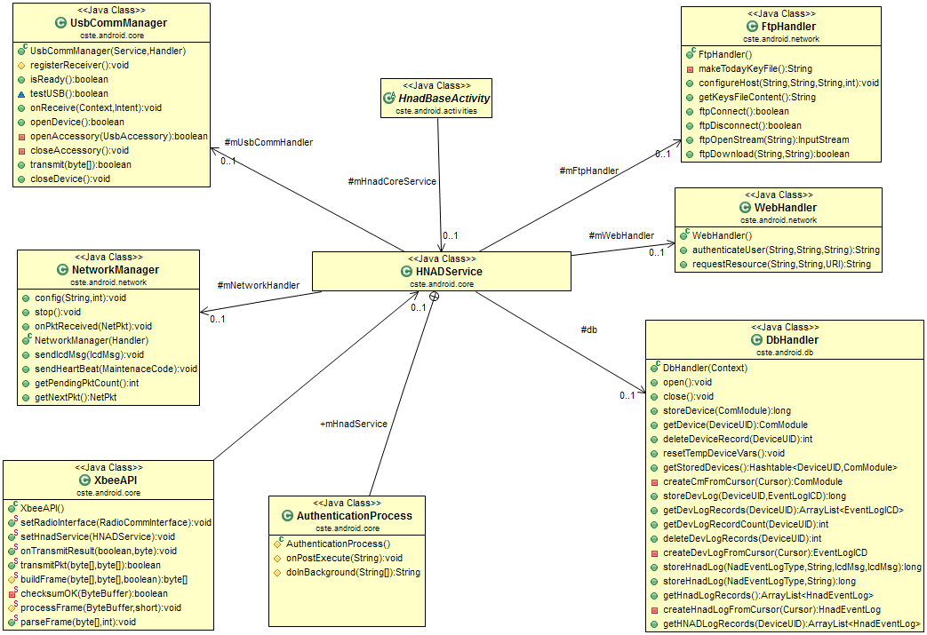
Figure 17: Relation between HNAD service and other system components

6.5.1 HNAD Service
The HNAD service is initialized when the application is first launched or when a USB accessory bearing the proper signature is connected to the Android device. At this point it will load the stored settings and initialize the objects listed on Figure 17. Should the user launch the application again or re-connect the USB device, the HNAD service will launch the login or devices in area activity depending on whether the user had been successfully authenticated. To assist in the debugging process, the HNAD service and its member objects make use the logging functionality provided by the Android API, and will log any events or errors based on their severity.
Since the HNAD service is not a separate process and runs on the same thread that updates the UI, all time consuming operations are executed on separate threads. When an activity makes a function call to perform one of these operations, an asynchronous reply bearing the response data will be done by sending a broadcast message. Table 1 lists the different broadcast types, their purpose and the data contained in them.
Table 1: HNAD broadcast messages
Broadcast type | Purpose | Payload
DEVICE_INFO_CHANGED | The status or some member variable of a device has changed due to the arrival of an external message | UID of affected device
DEVLIST_CHANGED | A new device is visible, or its record has been deleted from memory. | UID of new/removed device
LOGIN_RESULT | Result of an authentication attempt | Boolean
UPLOAD_DATA | Result of submitting data to the DCP over the internet | Boolean
USB_STATE_CHANGED | USB accessory has been disconnected/ connected | Boolean
TRANSMISSION_RESULT | Result of sending data to a device on the 802.15.4 wireless network | UID of destination, Boolean
ECM_EVENTLOG_CHANGE | A new device record was added | UID of affected device, Row ID
HNAD_EVENTLOG_CHANGE | A new HNAD record was added | Row ID

6.5.1.1 NADA Broadcaster
The most sign cant object stored in memory is the list of pending ICD messages that are pending to be transmitted over the 802.15.4 network, and those that have been sent an a response is yet to be received. According to the ICD specification, the HNAD should first announce that it has a message meant for a particular destination before transmitting it. This announcement is made by including the UID of the destination in the NADA broadcast that is transmitted at regular intervals. This is necessary because the CSDs are battery operated devices which go into sleep mode during a significant portion of their operation, so when it wakes up it will listen for the next NADA broadcast, and send a message to the HNAD telling it that it is ready to accept any buffered messages for it. Figure 18 illustrates the process for transmitting message from the HNAD to a CSD.
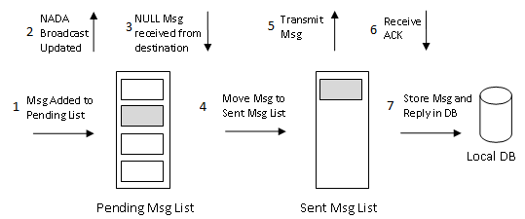
Figure 18: Event Sequence for transmitting ICD messages
The NADA broadcaster is a repeating timer event that is associated with the HNAD service, and its purpose is to transmit a NADA message over the 802.15.4 network at regular interval. This broadcast contains a sequence list with the UIDs of the destination devices that have messages for them on the Pending Msg List. If the user enables “Discovery Mode”, the NADA broadcast will also include the UID value 0xFFFFFFFFFFFFFFFF in its message waiting list. When a device sees its address, it will respond by transmitting a NULL message to the originator as if it had seen its own UID on the waiting list.

6.5.2 USB Control Process
The UsbCommManager is the process in charge of making use of the Android ADK API to transmit and receive data over the USB port. When the application is installed, its launcher activity will be registered with the OS as being suitable for handling the event of a USB-to-XBee accessory being connected to the handheld. When this takes place, this process will be able to read and write from the USB accessory as if it was a standard File object. To handle the transmission and receipt of data from the port, once the port is ready for use the following two threads will be started:
- USB Reader: This thread will continuously try to read from the port and store the result into a temporary buffer. A reference to his buffer is then passed to a previously registered IcdMessageHandler object, which in turn passes this data to the HNAD service. If there is no data available on the port, this thread will block until there is.
- USB Writer: When a call to transmit a message is made, the message will be pushed into a blocking queue structure. This thread will continuously attempt to pop the message and write it to the port. If the transmit queue is empty, this thread will then block.
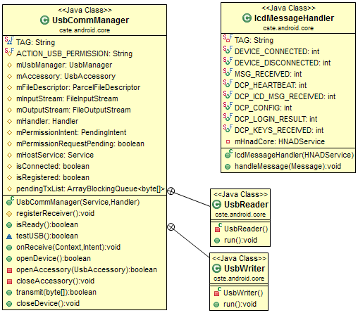
Figure 19: USB Manager components

6.5.3 XBee API
This class encapsulates a set of static function calls to generate a data frame that conforms to the Zigbee API mode as described in [4], as well as parsing the data received from the Xbee module. This application is currently requires that the attached XBee module be pre-configured into API mode 2. This operation mode makes it possible to specify the MAC address of the destination as well as retrieving the address and RSSI value of a received packet without needing to switch between standard and configuration modes. Figure 20 and Figure 21 display the structure that each Zigbee frames needs to follow before it is written to the XBee Module, or when a frame is received.
An additional function performed by the methods in this class is to perform the process of escaping a set of values which interfere with the operation of the XBee module. This is done by performing an XOR operation with the value and 0x20, and inserting the escape value of 0x7D before these values.
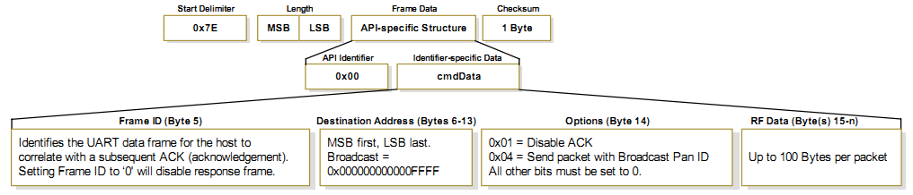
Figure 20: XBee API structure for 64-bit address transmission [2]

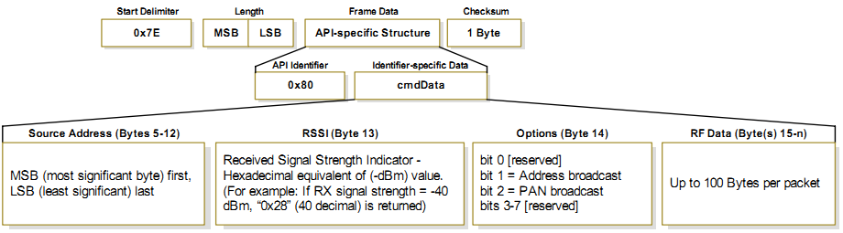
Figure 21: XBee API structure for a received frame

6.5.4 Database Handler
Long term data storage is done by storing this information into a local SQLite database file. This application’s storage requirements are simple, so it only requires managing the following three tables:
- Devices: Stores the device state and temporary keys using a simple byte blob and the UID of the device as the primary key.
- Device Logs: Stores the log messages received from a CSD device as a byte blob using the device UID and record ID as the primary key values.
- HNAD Logs: Stores the HNAD logs contents.
When the application is run for the first time, the database handler will the methods in the DbHelper class to create these tables and create the database file. The DbConst class only function is to store a set of static string values used to define the table and column names used. On a future implementation of this application it would be useful to encrypt the database file contents because if the handheld is rooted, it is possible for an external application to access the contents of this file.
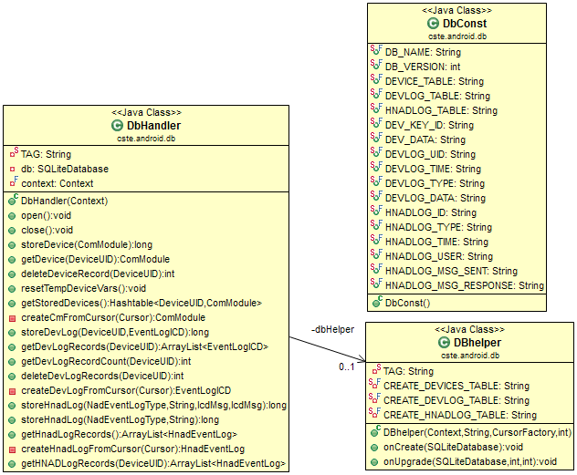
Figure 22: Database management classes

6.5.5 Network Components
The purpose of the following three classes is to handle the processes of sending and receiving messages over the internet. As of the data of the this writing, the only NAD to DCP communication that is specified is the forwarding of ICD messages over an IP network, and the transmission of periodic heartbeat messages to the DCP, and that the encryption keys be downloaded from a secure FTP server [5]. For this implementation it was decided to implement a simple web server to perform the task of user authentication, and communication with this web server is performed using the WebHandler object. Since communication over the network can take a long period of time, the HNAD service will not make direct calls to the methods of this class. Instead it will initiate an asynchronous task process which will in turn call the methods offered by these classes and process the received replies. Currently the only task supported is the process to authenticate a user and retrieve the encryption keys that were assigned to him from an FTP server. Figure 23 displays these three classes and their supported methods.
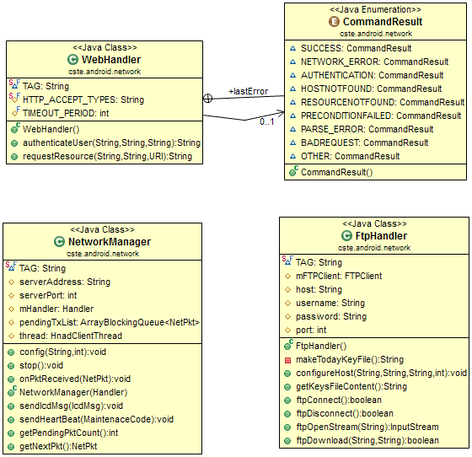
Figure 23: Network component classes

6.5.5.1 Web Client
This only method in this class is the one used to authenticate a user and read the reply from the specified server. This task is done be making an HTTP POST request which contains the username, password, and the UID of the handheld. The authentication server will check if these credentials are valid, and in which case it will reply to this client with a text sequence. This text value contains the necessary credentials and the address of an FTP server from which the assigned encryption keys can be obtained. In a future implementation this communication should be secured using a protocol like SSL to avoid the possibility of a third party using a packet sniffer to obtain these login credentials.

6.5.5.2 FTP Client
The only task performed by this object is to connect to an FTP server and attempt to download the specified file. According to the ICD specifications [5], the FTP server needs to maintain a separate home folder for each NAD, and which name is the same as the hexadecimal representation of the NAD’s UID. In this implementation, once the FTP client is connected to the FTP server, it will attempt to download the “keys.csv” file.

6.5.5.3 TCP Client
This object handles the task of making a TCP connection to the DCP server in order to transmit some specified payload. When a call to send a message is received, it will place this message into a blocking queue, and then send a notification to the HNAD service with the result. When initialized, this object will start a separate thread from which will attempt to connect to the DCP, and if successful it will enter an endless loop from where it will transmit the messages stored on the queue, and process the expected reply. If the transmission queue is empty, this thread will block until a new message is added.

6.6 ICD Message Handling
The following set of classes deal with the task of generating messages which follow the ICD specification, as well as parsing the arriving messages. Depending on the message type, it may be necessary to perform AES encryption/decryption on the payload before it can be processed by the application. To perform this task, the freely available Bouncy Castle Cryptographic library for Java was used.
Figure 24 displays the main IcdMsg class and its member variables. This class includes the following three public static methods:
- Configure: Used to specify the device type and UID to use when generating a new ICD message, and whether or not encryption should be enabled.
- BuildIcdMsg: This will generate an ICD message object based on the destination, the message type, and the parameters passed.
- ParseBytes: This will attempt to parse a byte array input into an ICD message object.
When this class is being configured, a reference to an implementation of the KeyProvider interface needs to be provided. This object in turn will handle the task of retrieving the necessary encryption key to decrypt or encrypt the payload of a given ICD message.
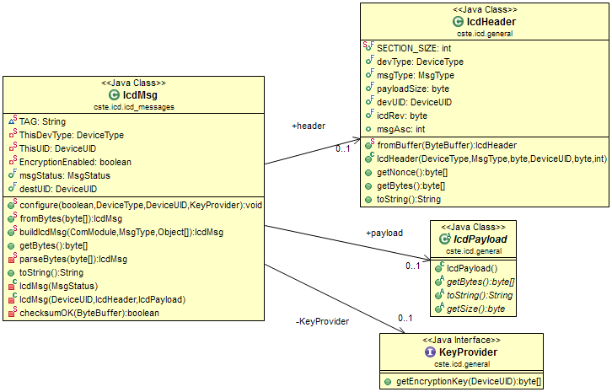
Figure 24: ICD Message class

6.6.3 ICD Message Payloads
Figure 25 displays all the currently supported ICD messages. Each ICD message object holds a reference to an IcdHeader and a IcdPayload object as its content. Exceptions to this are the NADA and NullMsg which do not follow the standard ICD frame format. The functionality required from each IcdPayload object is the following:
- Read its data content from a given byte buffer reference
- Provide a byte array representing its data content
- Provide a human readable string representation of its data content

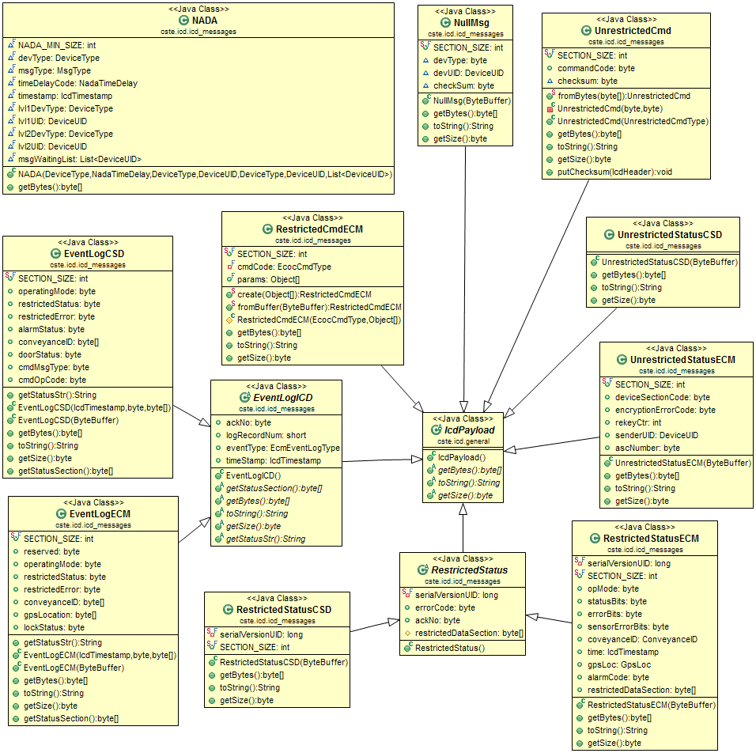
Figure 25: ICD 802.15.4 Message payloads

6.6.2 ICD Network Messages
The purpose for these messages is for encapsulating ICD messages from a 802.15.4 network, and transporting them to the DCP via some other network, for sending heartbeat messages to the DCP bearing updates on the operating status of a NAD, and for receiving a notification of a DCP configuration change. The NetPkt object operates in the same manner as the ICD message class in that it possess a header and a payload object, and supplies a method to create a net message based on the specified parameters. When a packet is received from the network, the payload will can be parsed into a NetPkt object which can then be passed to another section of the application for processing.
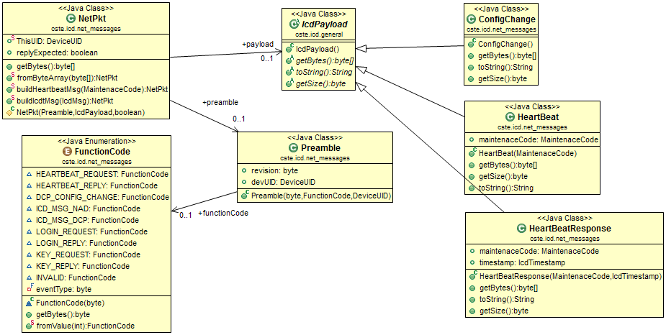
Figure 26: ICD network messages

CHAPTER 7
USB TO XBEE BRIDGE
The purpose of this custom adapter is to enable an Android powered handheld to communicate with other CSD devices using 802.15.4 radios. This is done by taking advantage of the Androids support for communication with other USB devices that adhere to the Android accessory protocol. When a compatible device is connected, Android enters a special accessory mode that permits the external device to act as the USB host, so it will need to possess its own power supply. The bride used in this project

7.1 Operation

Through the use of the applications manifest file it is possible to register a set of USB accessory profiles to identify when a compatible USB accessory is connected to the handheld. Each profile lists the manufactures, model, and the version number for each accessory that the application is designed to communicate with. Once the application has been installed in the system and the USB accessory is connected, the user will be prompted if he wishes to allow that this application receive permission to communicate with the USB device in the future, and in which case the application will be automatically launched whenever such a USB device is connected. After permission to communicate with the USB device is granted, the application can request to receive a notification from the OS whenever the USB state is changed. In operation the USB device can be accessed through the use of the standard file stream object provided by the Java library.

7.2 Components
The USB-to-XBee bridge used in this project was made using three commercially available parts that can be purchased from several electronics online stores:
- USB Host Shield
- Arduino FIO
- XBee RF module

7.2.1 USB Host board
MAX3421E
VDD
D+
D-
GND
Arduino FIO
XBee

VDD
GND
MOSI
MISO
SS
SCLK
VDD
GND
TX
RX

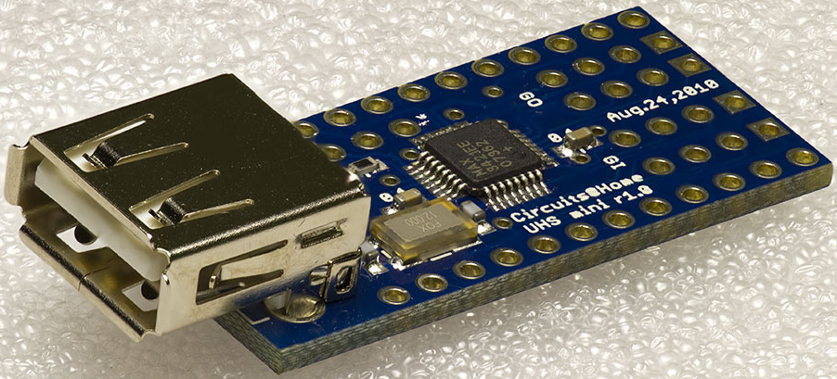
Figure 27: USB Host Shield for the Arduino Pro

Abc
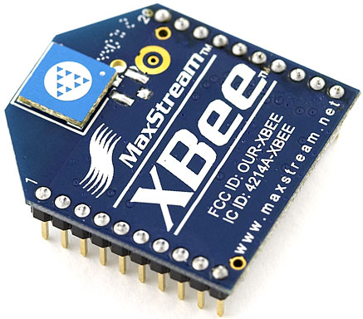
Figure 28: XBee RF Module

7.2.2 XBee RF Module
Abc

7.2.3 Arduino FIO Board
Abc

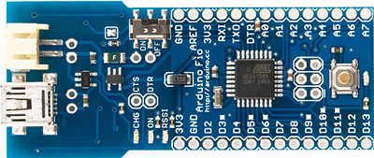
Figure 29: Arduino FIO board

CHAPTER 8
AUTHENTICATION WEB SERVER
Abc

8.1 Scope of Current Implementation
Abc

8.2 Administration Role
Abc

8.3 Authentication Process

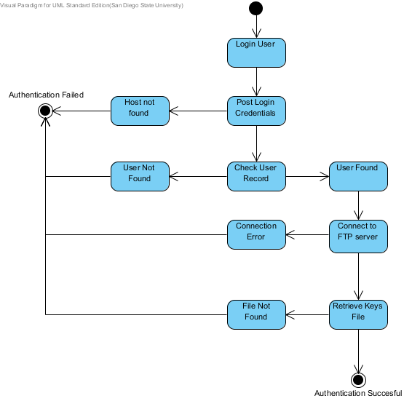
Figure 30: Login Steps
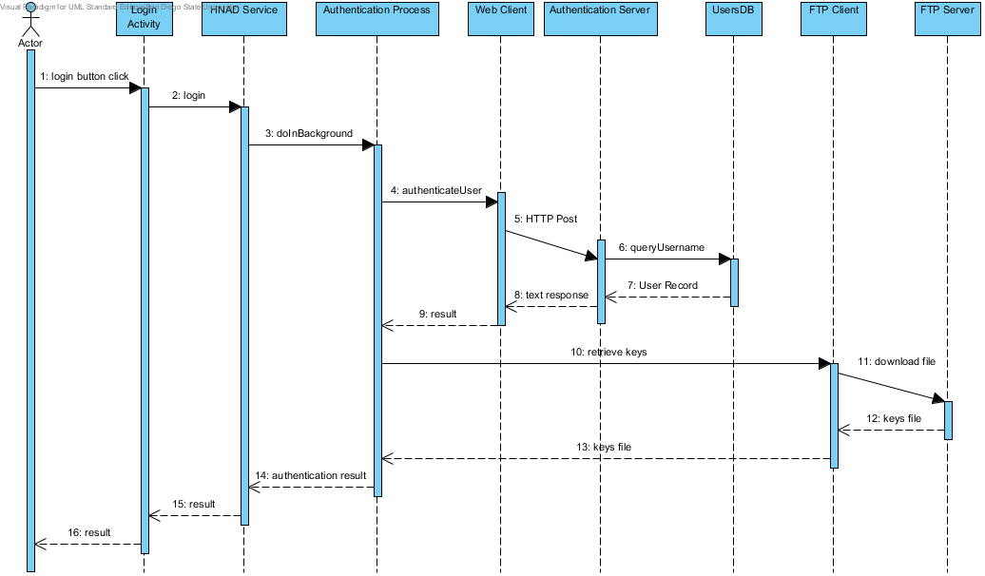
Figure 31: Authentication Sequence

8.3 Java Servlets Overview
Abc

8.4 Tomcat Server
Abc

8.5 FTP Server
Abc

8.6 Future Work
Abc

CHAPTER 9
CONCLUSION
Abc

BIBLIOGRAPHY
[1] K. Concepcion et al, Cargo Security Network Access Device (NAD) Requirements. San Diego: Space and Naval Command System Center, 2010.
[2] Android Developers Guide, “What is Android?” 2012. [Online]. Available: http://developer.android.com/guide/basics/what-is-android.html.[Accessed May 15, 2012].
[3] Ars Technica, “A developer’s introduction to Google Android” 2012. [Online]. Available: http://arstechnica.com/open-source/reviews/2009/02/an-introduction-to-google-android-for-developers.ars.[Accessed May 15, 2012].
[4] TODO, cite Zigbee Documentation
[5] TODO, cite DCP-NAP communications doc

